Gruffalo Class  Reception  Autumn A 26-27  CH and KB |  | Prime Areas |  |  |  |  | Specific Areas    WHOLE SCHOOL THEME: ‘Fantastic Foundations’  PSED: ‘Jigsaw’ theme: ‘Being Me in My World’  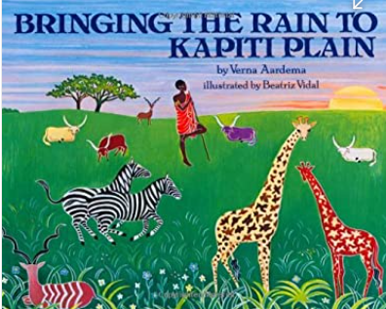  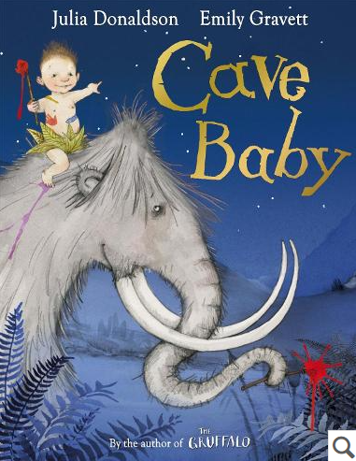  Literacy Tree Texts: ‘Cave Baby’  ‘Bringing the Rain to Kapiti Plain’  Story and Topic Question: ‘How do animals survive at night?’
Week /  Big Book |  | PSED | Physical Development | Communication  &  Language |  |  | Literacy | Little Wandle Phonics | Mathematics | Understanding  the world | Expressive  Arts & Design
Week 2  07.09.26  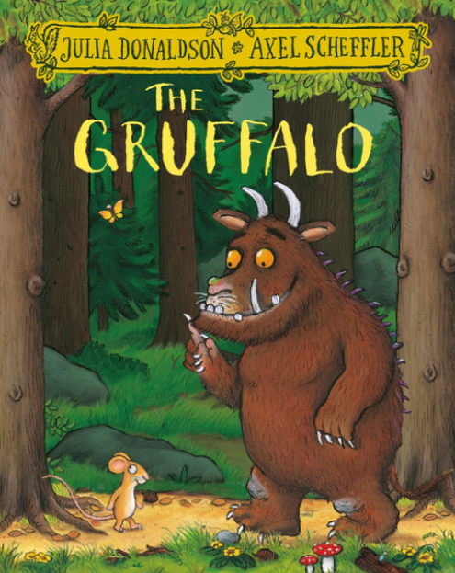  Theme Week: Welcome to Gruffalo Class  Focus book: The Gruffalo by Julia Donaldson  11.09.26 Rosh Hashanah |  | All groups: Create class rules, link to British Values – talk about behaviour chart  Experience -Play hide and seek  Routines of the school day – teaching lining up  PSED:  Introducing ourselves and our interests in all about me activities.  Introduce classroom environment and talk about classroom expectation and rules.  Discuss class community and talk about  Gruffalo family. | Fine motor focus:  Use of paintbrushes and art materials to make Gruffalo character collages.  Using tweezers to move pom pom and other small objects.  Gross motor movements when on Gruffalo adventure  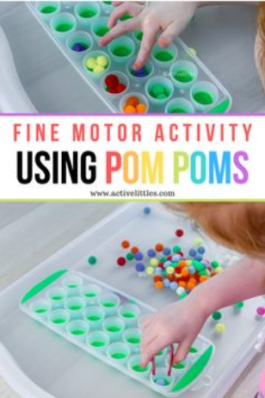  Dough Disco:  Precision and independence  Refined finger strength, bilateral coordination, tripod grip preparation  Finger push-ups, individual finger taps, rolling long thin snakes, making pre-writing shapes, cutting dough with scissors, phonics-linked dough challenges.  Handwriting progression (where appropriate) Practise letters in name | Listening to stories. Sitting together. Talking about the stories. Offering opinions and ideas.  Learn vocabulary related to the story of the Gruffalo  Joining in with nursery rhymes.  Listening to simple instructions  Washing hands and eating lunch appropriately.  Introducing themselves and talking about own interests. |  |  | Go on Gruffalo adventure and meet the characters.  Use actions to retell story.  Name the characters and identify body parts. Begin to describe body parts.  Name writing. | Foundation for phonics  Games.  Phonological awareness activities & games  Nursery rhyme box  Shared singing of action Nursery rhymes /songs and create rhythms using the musical instruments. | Getting to know you:  Opportunities for settling in, introducing the areas of provision and getting to know the children.  Key times of day, class routines. Exploring the continuous provision inside and out. Where do things belong? Positional language  White Rose Maths:  Step 4: Explore simple patterns  Step 5: Copy and continue simple patterns  Step 6: Create simple patterns | Gruffalo woodland experience: Go on a gruffalo walk and talk about the different settings he goes through.  Climate sustainability. | Routine songs – introduce the line up song  Starting school photographs/ handprints and drawings  Adding music to stories.  Gruffalo crafts to include: Gruffalo, mouse, fox, snake and owl painting, woodland tree collage, green handprints.  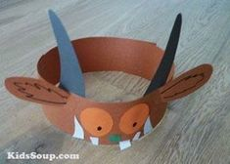  Using creative materials to represent the world and differences and similarities.  .
Week 3  14.09.26  Theme Week: My home family/My School family and community  Focus book: The Gruffalo by Julia Donaldson  *Reception baseline to be conducted where appropriate once children have settled. |  | Jigsaw:  Introduce the ‘Jigsaw’ PSHE scheme.  Jigsaw Puzzle: Being Me In my world. Piece 1  Who...Me?!  I understand how it feels to belong and that we are similar and different.  Talking about the importance of our families.  Talk about 3 similarities and differences between families. | PE: Sports coach  Teach dressing skills  Independence skills – Reading through the STC independence checklists – talking about how we will be learning and coming back to these skills throughout the year – display independence STC chart.  Dough Disco:  Precision and independence  Refined finger strength, bilateral coordination, tripod grip preparation  Finger push-ups, individual finger taps, rolling long thin snakes, making pre-writing shapes, cutting dough with scissors, phonics-linked dough challenges.  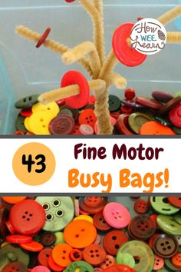  Handwriting progression (where appropriate) Practise letters in name and phonics letters taught. | Speaking and Listening teaching:  Understand how to listen carefully and why listening is important.  Learn new vocabulary.  Understand a question or instruction that has two parts, such as: “Get your coat and wait at the door”. |  |  | Name writing  Drawing and labelling the names of people in my family. | Little  Wandle  Autumn 1  s a t p | Number blocks: Number 1 and 2.  Number counting songs to 10:  One, Two, Buckle My Shoe  "One, two, buckle my shoe; three, four, shut the door..."  Ten Little Fingers  1, 2, 3, 4, 5, Once I Caught a Fish Alive  The Ants Go Marching  Counts up from 1 to 10 as more ants join the march.  Ten Green Bottles  Five Little Ducks  White Rose Maths:  Step 4: Explore simple patterns  Step 5: Copy and continue simple patterns  Step 6: Create simple patterns | Discussing our families and who lives in our house.  Describing their mums – talking about the correct colours for hair, skin colour, eyes etc. | All groups: My mum / my special person pictures – teaching how to draw simple person  All Group. Christmas card project.  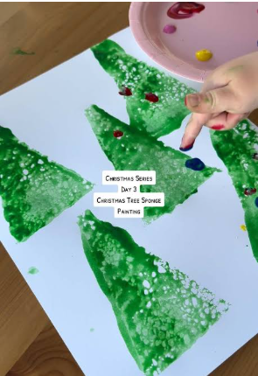  Music session:  Kapow Music Unit: Exploring Sound  Vocal sounds  To explore using voices to make a variety of sounds.
Week 4  21.09.26  Theme Week: Climate Sustainability – home and school environment  Focus book: The Gruffalo by Julia Donaldson  *Reception baseline to be conducted where appropriate once children have settled. |  | Jigsaw:  Jigsaw: Piece 2: Being me in My World: ‘How am I feeling today’?  I can start to recognise and manage my feelings.  Name and talk about our feelings.  Set ourselves a goal for over this half term – what would I like to achieve?  Record on paper – add to PSHE display? Talk about our own abilities. | PE: Sports coach  Teach dressing skills  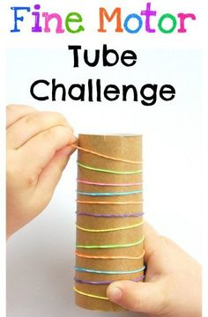  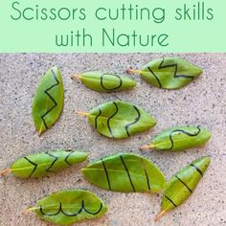  Dough Disco:  Precision and independence  Refined finger strength, bilateral coordination, tripod grip preparation  Finger push-ups, individual finger taps, rolling long thin snakes, making pre-writing shapes, cutting dough with scissors, phonics-linked dough challenges.  Handwriting progression (where appropriate) Practise letters in name and phonics letters taught. | Speaking and Listening teaching:  Understand how to listen carefully and why listening is important.  Learn new vocabulary.  Understand a question or instruction that has two parts, such as: “Get your coat and wait at the door”. |  |  | Session 1  Session 1 on Literacy Tree – WOW  Arrive to class to find several cave paintings on the  walls… someone has been painting on the classroom  walls! How naughty!  Share an example of a time you have done something  ‘naughty’, e.g. eaten a whole bar of chocolate just  before dinner or made a mess in your bedroom and  not tidied it up!  Model asking TA (if you have one) about a naughty  thing they have done.  Ask children to discuss in talking partners something  they have done that was ‘naughty’. Share with class  and discuss. As children share their ideas, record ideas  and add these to the working wall.  Activity: Build a cave using construction- what does a cave look like- look at different pictures.  Have post it notes (small paper) to make a drawing for inside their cave.  Session 2  Look at pictures of caves. What does a cave look like? What animals might they see?  Children to make their own drawing of a cave.  Artwork- write their name on their artwork.  Session 3  Children to draw mammoth. Discuss what a mammoth looks like. Share photos of these. Children to name body parts of a mammoth and use actions to identify these. Can they hear the initial sound? Children  describe the mammoth. Where might we see a mammoth? Would you like to ride a mammoth? Why?  Artwork- write their name on their artwork. | Little  Wandle  Autumn 1  i n m d | Number blocks: Number 3 and 4.  Number counting songs to 10:  One, Two, Buckle My Shoe  "One, two, buckle my shoe; three, four, shut the door..."  Ten Little Fingers  1, 2, 3, 4, 5, Once I Caught a Fish Alive  The Ants Go Marching  Counts up from 1 to 10 as more ants join the march.  Ten Green Bottles  Five Little Ducks  White Rose Maths:  Step 4: Explore simple patterns  Step 5: Copy and continue simple patterns  Step 6: Create simple patterns | Climate sustainability – what can we do in our classroom to look after our school environment?  What could we do at home to protect our home environments and our world.  Turning off the taps to save water  Turning off the lights when not needed  Recycle | Music session:  Kapow Music Unit: Exploring Sound  Body sounds  To explore using body parts to make a variety of sounds.
Week 5  28.09.26  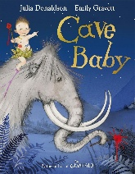  Focus book: Cave Baby by Julia Donaldson  Literacy Tree outcome: Narrative retelling  30.09.26 Bridgwater Fair starts. Welly walk and picnic lunch  02.10.26 National poetry day |  | PSHE:  Jigsaw: Piece 3: Being me in My World: Being at School  I enjoy working with others to make school a good place to be. | PE:  Teach dressing skills  Dough Disco:  Precision and independence  Refined finger strength, bilateral coordination, tripod grip preparation  Finger push-ups, individual finger taps, rolling long thin snakes, making pre-writing shapes, cutting dough with scissors, phonics-linked dough challenges.  Handwriting progression (where appropriate) Practise letters in name and phonics letters taught. | Speaking and Listening teaching:  Understand how to listen carefully and why listening is important.  Learn new vocabulary.  Understand a question or instruction that has two parts, such as: “Get your coat and wait at the door”. |  |  | Session 1  Children to read the beginning of the story up to the part where he find a paint pot. Children to act out the story using actions and immersing themselves in the language. Discuss what the opening tells us- it introduces the character and the setting. Discuss the different characters. How do you think they are feeling?  Activity: I wonder what he will do with the paintbrush? Children to draw/paint what they think they will do with this. (think about they are in a cave).  Session 2:  Read the next part of the story to discover what the cave baby has painted. Discuss the different characters the story the introduces. Read the rest of the story a  Characters within the opening of the story.  Discuss the characters within the story. What is a character? Identify initial sounds of the characters.  Choose the cave baby- the main character.  Name their artwork – using their name, practising name writing.  Session 3:  Discuss today we are going to sequence the main events the cave baby is included within. Who does the cave baby meet within the story?  Recall the key events within the story. Where is the story set? What characters are within each sequence? Have 4 or 5 key events photocopied from the book. Can the children order these events as a group. Children to orally compose a simple sentence to talk about each story. Can children use an action to create this? | Little  Wandle  Autumn 1  g o c k  Tricky word ‘is’ | Mastering number: Subitising  To be able to subitise 1 and 2  To be able to subitise within 3  To be able to represent quantities  To be able to identify sub-groups of 1, 2, and 3 | Session 1:  Discuss day/night and light/dark  Engage in small world space set up (stars/night)  Go on daytime walk (experiences include; leaf jumping, collecting flowers and making a picture and looking for natural materials.  Session 2:  Name sources of light including sun. torches, stars and lights.  Explore torches and other sources of light e.g sun, stars and lights. Look at night-time videos make a night-time painting. Can they include any sources of light in the picture?  Engage in small world space set up (stars/night)  Session 3:  Discover nocturnal animals and describe features including owls, bats, badgers, hedgehogs and foxes.  Talk about the family connections within the owl babies story and discuss similarities and differences across our families  Use internet to research owls, look at owl photos, sounds and videos.  What do owls eat? Where do they live?  Discuss lifecycle of an owl and use creative materials to represent this.  Sorting nocturnal and diurnal animals  Create a leaf art with focus on making a picture of a nocturnal animal. | Music session:  Kapow Music Unit: Exploring Sound  Instrumental sounds  To explore using instruments to make a variety of sounds.  Create leaf art with focus on making a picture of a nocturnal animal or a feature of the woodland habitat.  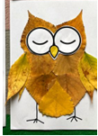
Week 6  05.10.26  Focus book: Cave Baby by Julia Donaldson  Literacy Tree outcome: Narrative retelling  07.10.26 Harvest Festival – Church assembly  Wear Autumn colours to raise funds for the women’s refuge  Black History Month  09.,10.26 World Mental Health Day |  | Jigsaw:  Jigsaw: Piece 4: Being in My World: Gentle Hands:  I understand why it is good to be kind and use gentle hands.  Talking about friendships – showing sensitivity to other chns feelings.  Check on our half termly goals – talk about resilience and perseverance. | PE: Sports coach  Teach dressing skills  Dough Disco:  Precision and independence  Refined finger strength, bilateral coordination, tripod grip preparation  Finger push-ups, individual finger taps, rolling long thin snakes, making pre-writing shapes, cutting dough with scissors, phonics-linked dough challenges.  Handwriting progression (where appropriate) Practise letters in name and phonics letters taught. | Speaking and Listening teaching:  Understand how to listen carefully and why listening is important.  Learn new vocabulary.  Understand a question or instruction that has two parts, such as: “Get your coat and wait at the door”. |  |  | Session 1  Recall the story using story narrative language, applying key sentences taught from sequencing last week. Who are the characters? Where is the story set?  Explain how we will be focussing on another character from the story.  Focussed drawing element: Teach children how to draw a tiger and children to then draw independently. Children to focus on the tiger (t- taught in phonics lessons). Can they identify any other initial sounds for this character’s appearance? Can they describe him. As a group compose a short sentence character description. ‘The tiger is stripy and fast.  Children to write their name on their drawing.  Session 2  Retell the story using story narrative language, applying key sentences taught. Question what is a character?  Focussed drawing element: drawing a hare. Teach art skill and children to draw this independently. Can they identify initial sounds for the hare? Can they describe the hare? As a group compose a short sentence character description.  The hare has long ears and soft fur.  Children to write their name on their drawing.  Session 3  Focussed drawing element: drawing a hyena. Teach art skill and children to draw this independently. Can they identify initial sounds for the hyena? Can they describe the hyena? As a group compose a short sentence character description.  Children to write their name on their drawing. | Little  Wandle  Autumn 1  ck e u r  Tricky word ‘I’ | Mastering number:  Counting, Cardinality and Subitising  To be able to count in a sequence to 5  To be able to count in a sequence to 5 (how many)  To be able to count one to one  To be able to count one to one | Session 1  Discuss similarities and differences across habitats in relation to woodlands. Name and describe features of animals within a woodland habitat.(Barnaby Bear)  Use senses to explore woodland habitat- hear, see, smell, taste, feel.  Listen to videos of sounds in a woodland area.  Look at young and adult animals within families. Match young and adult animals. Talk about growth and make links to features of animals.  Session 2  Draw a tree and label this.  Children to go out to the Forest school area and draw and label a tree. Model this first. Discuss the key vocabulary that we will need to label our tree e.g. trunk, roots, leaves, branches etc.  Session 3  Participate in a ‘camping’ style activity where children can experience camping, den building, hot chocolate etc. (Barnaby Bear)  Talk about care to care for the natural world.  Participate in a ‘camping style’ activity where children can experience camping, den building. Hot chocolate and other camping style games. (team building). Including experiences such as mud pies, box sledging, rolling down a hill, playing a board game, listening to a book under a tree and den building. | Music session:  Kapow Music Unit: Exploring Sound  Environmental sounds  To explore sounds within the environment  Drawing skills: draw a tree and label the parts.
Week 7  12.10.26  Assessment Week    Fantastic Finishers |  | Jigsaw:  Piece 5: Being me in My World:  Our Rights:  I am starting to understand children’s rights, and this means we should all be allowed to learn and play.  Talk about self-confidence and having our own voice. | PE: Sports Coach  Teach dressing skills  Dough Disco:  Precision and independence  Refined finger strength, bilateral coordination, tripod grip preparation  Finger push-ups, individual finger taps, rolling long thin snakes, making pre-writing shapes, cutting dough with scissors, phonics-linked dough challenges.  Handwriting progression (where appropriate) Practise letters in name and phonics letters taught. | Speaking and Listening teaching:  Understand how to listen carefully and why listening is important.  Learn new vocabulary.  Understand a question or instruction that has two parts, such as: “Get your coat and wait at the door”. |  |  | Session 1/ 2  Children to create their own character (animal) to hang up around in another class to make a mess. Children to have a selection of real-life objects and STC to choose their animal. Can children identify initial sounds. Label the character. | Little  Wandle  Autumn 1  h b f l  Tricky word ‘the’. | Mastering number:  Composition  To be able to understand the composition of 2  To be able to identify a composition of 3  To be able to identify a composition of 3 (2nd part)  To be able to identify when a collection is composed of 3 or not 3 | Fantastic finishers booklets.  Technology: Remind children of E-Safety rules whilst using technology. (Active Bytes)  Talk about E-Safety and how to stay safe online by not clicking on things you are unsure about and understanding what a trusted adult is. Use the laptop computers to research nocturnal animals. Look at photographs, listen to animal sounds and videos of nocturnal animals. | Fantastic finishers booklets.  Music session:  Kapow Music Unit: Exploring Sound  Nature sounds  To listen to sounds in nature and recreate them.
Week 8  19.10.26  Theme Week: Fantastic Foundations |  | Jigsaw:  Jigsaw: Piece 6: Being me in My World:  Our Responsibilities  I am learning what being responsible means.  Check in on half termly goals – did I achieve my goal? How do I feel? What are my next steps? | PE: Sports coach  Teach dressing skills  Dough Disco:  Precision and independence  Refined finger strength, bilateral coordination, tripod grip preparation  Finger push-ups, individual finger taps, rolling long thin snakes, making pre-writing shapes, cutting dough with scissors, phonics-linked dough challenges.  Handwriting progression (where appropriate) Practise letters in name and phonics letters taught. | Speaking and Listening teaching:  Understand how to listen carefully and why listening is important.  Learn new vocabulary.  Understand a question or instruction that has two parts, such as: “Get your coat and wait at the door”. |  |  | Whole school theme week (add to this). | Little Wandle Phonics assessment | Mastering Number:  Subitising (1 session) Comparison (3 sessions)  To be able to: Subitise arrangements of 2 and 3 Practise making 2s and 3s with their fingers Subitise auditory patterns up to 3.  To be able to: Subitise auditory patterns up to 3 Identify when a small collection is rearranged or the quantity changed.  To be able to: Show small quantities on their fingers Use positional language to describe patterns of 4.  To be able to Use positional language to describe patterns of 4. Make patterns showing 4 | Whole school theme week (add to this). | Whole school theme week (add to this).
HALF-TERM HOLIDAY: 26/10/26-30/10/26

