Literacy Medium Term Planning Percy the Park Keeper Year 1 Autumn A 2024 2025

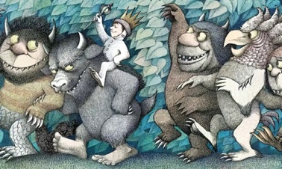
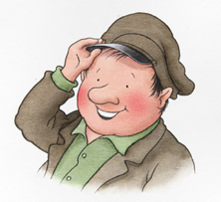
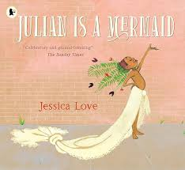

 | Text | Genre | Focus
Fiction/Poetry | Where the Wild Things Are  Julian is a Mermaid |  | Own Version narrative  Three verse poem

Immersion in the text | Working with the text | Vocabulary | Ideas for teaching
WTWTA  Role-play area with home corner and bedroom.  Children to role-play being a wild thing.  Children to role play being Max.  Children to investigate books about boats.  Children to make predictions about the ending of the book from understanding story so far.  Children to create a wild thing and name it.  JIAM  Children to role-play their dreams.  Children to make predictions about the story.  Children to consider the things they would like to be/do when they grow up.  Children to describe things they like about themselves.  Children to share experiences of a time they made someone proud.  Children to experience different poems and poets in the reading corner. | Astro Girl  Retelling the story with actions.  Role-playing the story in the role-play area.  Discuss writing for different purposes.  Compose a variety of sentences mentally before writing.  Use a variety of sentence starters within a text.  Use capital letters and full stops.  Add adjectives to nouns to create noun phrases.  Spell some year one tricky words correctly.  JIAM  Re-telling the story using illustrations and human timeline.  Role-playing freeze frames from the story.  Discuss writing for different purposes (commands)  Use a variety of sentence starters within a text.  Understand and use verbs to write commands.  Use suffixes to create progressive verbs. | WTWTA  Wild jungle forest bedroom dinner claws crown king  Noun adjective noun phrase narrative story imagination real  JIAM  Mermaid dreams wishes trouble majestic daydream imagine  Poem stanza repeating verb suffix progressive verb | WTWTA  Ideas for retelling a story, pictures, actions.  Using imagination to create a wild thing. What do they look like? Where do they live?  How do we make a story interesting? How can we help the reader to see what we have imagined?  JIAM  Children think about what they would like to be when they grow up. What commands would you give someone who wanted to do that job? What actions do you need to do that job? How would it feel of your dream became real?  Children to think about how their grown ups would feel if they follow their dream?  Children to discuss how it feels if someone is mean to you for being yourself or for following your dream? What might happen to someone if another person makes them feel bad about who they ae or what they dream? Why is it important to be kind to each other?
Author focus – Dr Seuss

Week | Speaking & Listening | Planning | SPAG | Outcome/ audience
1  04/09-06/09 |  | Theme week – Reading for pleasure – See separate planning.
2  09/09-13/09 |  | Theme week – Reading for pleasure – See separate planning.
3  16/09-20/09 | Children to use talking partners to share their thoughts about who or what might have been in the classroom and left the footprints etc.  Answer questions and make predictions about the story. E.g Why do you think Max was sent to bed without any dinner?  Children to role play being a ‘wild thing’ using appropriate voices and movements.  Children to role play being ‘Max’ in a crown and giving instructions to the wild things (like Simon says but Max says).  Children to use talking partners to describe their own experiences of a time when they day-dreamed to make themselves feel better.  Children to orally re-tell the story with their talking partner.  Children to re-tell the story to their talking partner. Children to use the actions when re-telling. | Where the Wild Things Are  Mon – Children arrive to class to find evidence (footprints, a small clump of fur, a large bite-mark out of paper on the display board etc.) that some kind of creature has been there. Who/what do they think it might have been?  Discover a sack labelled Sam’s stuff containing a story-book (Where the Wild Things Are), a sandwich, a strawberry and a letter S – it would be good if this was tactile ie cut out of velvet or sandpaper so that children can trace the shape. Who or what has been in class must have dropped this! Create labels (Children to write labels on whiteboards) for each of the objects, ensuring that you use only lower case letters save for the name ‘Sam’. Read the story up to …and he sailed off through night and day…  Why do you think Max was sent to bed without anything to eat?  What do the children think might happen next? Hmmm.  We found a sack but it’s Sam’s not Max’s…. Maybe Sam is hiding and he’ll come back for his stuff!  Children to write as many items from the classroom that have the phoneme ‘s’ into their journals.  Weds – Read from the beginning of the story again, this time, going up to the double page that begins ‘And when he came…’ to ‘and showed their terrible claws’. Let’s pretend: Let the children become Wild Things, with you as their leader: Command the wild things to Roooaarrr! Command them to gnash! Command them to roll their terrible eyes and show their terrible claws! Now command that they sssssss and then ahhhhhhh.  Read on to and made him king of all the wild things Well – we thought that Max would be eaten but the wild things have made him their king!  Play another round of Let’s Pretend, this time letting children assume the role of Max the king. Have a crown for the children to wear as they do this. Children to command in ‘Simon says’ but saying ‘Max says…..’  Display an enlarged picture of one of the wild things that you have labelled ‘Sam’. Oh so this is Sam? He dropped the sack!  In front of the children, write the following sentence onto a strip: Stripy, scaly Sam likes stories, strawberries and sandwiches.  Read the sentence out-loud several times, encouraging the children to join in. Say it loudly, say it quietly.  Discuss other ‘s’ adjectives that might describe Sam. Children to write their own description of Sam into their journals.  Thurs – Re-cap the story so far: Max was miserable when he set off, wasn’t he? Why was this? But he met the wild things, became king and had a wonderful rumpus with them. I think that this story will have a happy ending because he’s found some friends…  Display the illustration from the point Max sends the wild things to bed without their supper. Elicit that while the wild things all look tired but happy, Max looks really unhappy! Read the text that accompanies this page. Why do you think Max sent the wild things off to bed without anything to eat? Where do you think Max wants to be? How do you think the story will end?  Read to the end of the story. Have the children ever felt a bit like Max did and day -dreamed to make themselves feel better?  Look at 6 pictures from the story. Make up actions to re-tell the story from the pictures. Children to join in the actions. Remind children that they need to use a capital letter at the start of their sentence and a full stop at the end.  Children to arrange 6 key pictures from the story into the correct order. Cut and stick them into their journal and write a sentence (or a word) under each to describe what is happening in the story.  Fri – Show children how to look at the previous days work now that it has been marked. Show them how to find the corrections that have been made. Explain children need to use these corrections when they write up their work into their blue book.  Using their story sequences from the previous day, children to retell the story into their blue books independently, using their marked journal to make any corrections. | Children to practice writing the long date into their journal copying the correct spelling and using a capital letter for day and month.  Children to understand what is an ‘adjective’ and choose their own adjectives to describe Sam.  Children to write a sentence with a capital letter and a full stop.  Children to use best handwriting.  Children to use capital letters and full stops. | Children to answer questions appropriately.  Children to identify objects with the correct phoneme.  Children to use adjectives to describe Sam.  Children to sequence the story correctly and independently describe what is happening in each picture.  Children to re-tell the narrative of WTWTA into their blue books independently.
4  23/09-27/09 | Children to share their ideas about their own wild thing with their talking partners. Children to share with class if they choose.  Children to share ideas for their own stories with their talking partners.  Children to share their imaginary ideas.  Children to describe which parts of the story might be real and which might be imaginary. | Where the Wild Things Are  Mon – Have pictures of the Wild Things from the book. Children to give each Wild Thing a name (this could be a nonsense word). Children to create their own wild thing, drawing first, then write a sentence to describe their Wild Thing using ‘and’,  e.g. My Wild Thing is called Froob and he has blue hair.  Children can then colour in their wild thing.  Weds – Children to plan a story where their character goes to see the Wild Things.  What is your character called?  What did they do to get told off?  What appeared in their bedroom?  What happened on Wild Thing Island?  What happened when they got home?  Children to write their story plans into the boxes.  Thurs – Children to draw the key pictures from their own stories into the story frame (children should be familiar as they will have used the story frame in the re-telling) using their plans to sequence the events.  Fri – Children to write the story under each picture using noun phrases to make their story more interesting.  E.g. a dark green forest appeared, the wild things had sharp teeth etc. | Children to use the conjunction ‘and’ in their writing.  Children to use adjectives to add to nouns to create noun phrases (blue hair).  Children to use noun phrases to add depth and detail to their stories. | Children to show imagination when creating their wild thing. Children to match their drawing to appropriate writing (if written pink hair has coloured the hair pink etc)  Children to begin to plan their own narrative, sequencing the events appropriately.  Children to use imagination to add details to their story plans.  Children to begin to write their own narrative in simple sentences.
5  30/09-04/10 | Children discuss their story, creating actions to re-tell their story with their talking partner. Children volunteer to share with the rest of the class. | Where the Wild Things Are - Assessment  Mon -Discuss the rules of writing with the children. Remind them the sentences need a capital letter and a full stop. Writing needs to sit on the lines and stay between the lines. Use the whole line etc.  Challenge children to use the conjunction ‘and’ in their writing. Explain children are going to write their stories onto special paper that will go in their ‘best’ book. Demonstrate how to use their marked plans with corrections to write their story. Children to begin writing their assessment piece.  Weds – Children to continue writing their own wild things story. Children can design a front cover for their story when they have finished.  Thurs and Fri – Provide children with a blank book. Children to turn their story into a book. | Further practice using capital letters and full stops.  . | Children to write their own narratives for assessment.
6  07/10-11/10 | Children to share their feelings and ideas about their dreams. Children to listen to each other and take turns to speak.  Children to play Simon says. Children need to listen for the instruction that starts with ‘Simon says’. Children to understand they are giving commands using verbs to tell each other what to do.  Children to discuss the verbs they used when listening to the mermaid music. Children to share which verbs they enjoyed the most. | Julian is a Mermaid  Mon - Arrive to class to find a scattering of shells, maybe a bit of sand and an ocean-bed treasure-chest and let the children discover a scroll tied with some sea-grass and decorated with a shell amongst the sea-side objects. Share the letter:  Dear children, In life, you must follow your dreams. Be who you are and who you wish to be. Use your imagination and maybe one day your dreams will come true. Above all, be yourself. Dream well, Wise fish Naima*  * means ‘wisdom’  Ensure children understand what is meant by imagination. Check they understand the two meanings of dreams.  Orally rehearse some responses using a talking frame:  I dream of … and …  My wish is to …and …  I hope that I …  Let the children practice writing these sentences and then choose 1 to record their dream onto notelets that have been shaped like shells.  Ceremoniously place the dreams into the treasure-chest, asking that the children say them out-loud if they would like to.  Weds – Tell the children that all this talk of dreams and being all you want to be has reminded you of a story. Share the story, Julian is a mermaid by Jessica Love, reading up to the page where Julian daydreams he becomes a mermaid and the majestic fish presents him with the coral necklace. Ask the children, What’s just happened to Julian? What has he been doing?  Elicit that Julian has had a daydream, imagining becoming a beautiful mermaid. Let’s be mermaids! Play some underwater music such as The Aquarium from Saint-Saëns’s Carnival of the Animals suite. Let the children move to the music and, using verbs as commands, ask the children to swirl, swim, float, swish, whirl, flip, turn, swoosh to the music.  Oral dictation: read the verbs as a list of ‘mermaid movements’ and let the children write each movement word (verb) Mermaids flip. Write flip. Mermaids swirl. Write swirl. Etc  Thurs - Tell the children that as well as the beautiful necklace, the majestic fish presented Julian with a shell and in that shell was a message from the fish- goddess giving instructions on how to move like a mermaid. The problem is that the message has become wet and Julian can’t read it. Can the children help by re-writing some instructions on being a mermaid? Revisit the verbs that the children explored in session 2.  Model writing a couple of command sentences using verbs at the beginning of each and writing as a list of instructions.  e.g. Swim down to the ocean bed. Float with the fish.  Let the children continue to write commands for each picture, placing their verbs at the beginning of the sentence.  Children can check each others work for capital letters and full stops.  Fri – Re-read the text from the beginning up to the page where Julian says: Nana, I am also a mermaid. Ask, what do you think will happen next? What might happen when an adult says to a child ‘be good’ before leaving the child alone? Share the next 6 pages from Julian has an idea to his ‘ta-da’ picture where he stands wearing the costume that he has fashioned out of everyday objects and Nana reappears… Thought-tapping:  How might Julian have been feeling when he was getting the costume on and how do the children think he now feels at this moment when Nana has ‘caught’ him and is walking away?  Elicit that he felt excited and proud at his idea, pleased that he had transformed himself into a mermaid and then ashamed as he feels he’s in trouble. Let the children freeze-frame Julian having the idea; Julian realising the idea and then Julian being ‘caught’. Thought-tap the children at each stage. How might Julian’s feelings have changed?  What were they thinking: Provide the children with the What were they thinking resource (attached at the back of the sequence). Let them write in role as Julian what was going through his mind when he had the idea; as he transformed himself into a mermaid and then what was going through his mind as he realised he had damaged the plant, had taken down the curtains and had used Nana’s lipstick without permission.  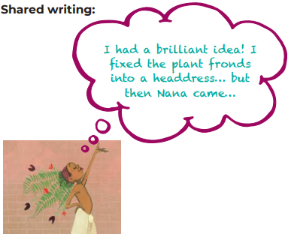  What do the children think Julian’s Nana was thinking at this point, given that we can see her disappearing off the edge of the page? Where might she be going? What do you think she’s going to do? | Children to use the conjunction ‘and’.  Children to understand that a verb is a ‘doing word’. Children to respond to verbs to completing the action.  Children to write sentences starting with a verb. | Children to recognize their dreams and construct them into a sentence using the talking frame to structure their sentences.  Children to write single words from dictation using their phonics to write the word phonetically plausibly.  Children to write command sentences.
7  14/10-18/10 | Children to think of a time they made their grown ups proud. Children to share the experience with their talking partners.  Children to show their creativity and imagination when moving to the music. What/who are they? What are they doing?  Children to remember the verbs used previously and use them to describe their characters actions. | Julian is a Mermaid  Mon - Read the next double page up to Come here, honey. Tell the children that when someone calls a child ‘honey’ it is meant kindly and that Nana doesn’t seem that cross. Suggest that the reason she left the room was to get dressed. Do they think that Julian is in big trouble or not? Read to the next page, For me, Nana? Oh look! The fabric of Nana’s dress is the same as the skin on the majestic fish in the daydream sequence! And, just like the fish that Julian imagined, Nana is giving Julian a necklace to finish off his costume. Explore the picture where Nana and Julian are descending the stairs, hand in hand. Tell the children that you don’t think Nana is cross with Julian and also that she is proud of him. Can the children find clues in the picture that tell the reader this?  Say what you see: Provide children with copies of the illustration and the statements that are attached to this planning sequence. Let them decide which statements ‘fit’ and which do not. Let the children write the ones that describe what is happening onto/beside the picture.  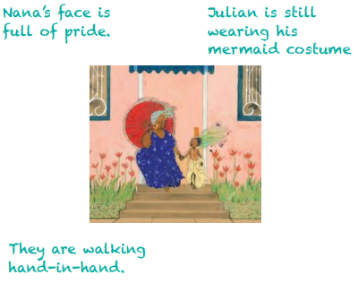  Take responses, modelling orally how we can use clues from the words and pictures in a book to make decisions (inferences) about how a character is feeling e.g. Julian is still wearing his costume so Nana isn’t cross at what he’s wearing. Share the story to the end.  Weds - Play some traditional South American/ Caribbean Carnival music like samba or soca that’s got a good beat to it How does it feel? What is it like? Talk about feeling free; using imagination and being creative and ask the children to think about who or what they were in that carnival costume. Return to the text, re-reading the whole story and pausing at phrases such as, Nana, I am also a mermaid and the bit where Nana says to Julian: Like you, honey. Let’s join them. Play the music again and this time, stop the music intermittently. When you do, tap the children on the shoulder and ask them to say what they are  e.g. I am a fish. I am a flamingo  Share with the children the poem, The River by Valerie Bloom. We have selected this poem as it has a four-line structure; verbs have been used in a similar way to how the children will be using them when they write their own poems and there’s an element of repetition. Can the children identify the words that have been repeated? What are they? Talk about the rhythm and ‘beat’ of the poem; discuss how it has been set out on the page. Make links to maths by ensuring children know the ordinal numbers, first, second, third and fourth as this will help with the discussion about the poem and also with the setting out when the children come to write their own poems.  Tell the children that they are going to write a poem over the next few days using the ideas explored around costumes, carnivals, dance and being yourself. Drawing upon the oral rehearsal in the whole class session, let the children write their poem title using  Julian is a mermaid  as a frame: Carl is a flamingo  Thurs - Revisit the verbs that the children used in sessions 2 and 3. Model writing some statements that were orally rehearsed when you’d stopped the music and then adding further statements that incorporate the words with adjacent consonants and r-controlled vowels:  I am a flamingo.  I swirl and I swoosh.  Swirl, swoosh, swirl, swoosh.  Freedom!  Tell the children that you have set this out like a poem, where you are writing one sentence/phrase or word per line on the page as that’s what poems look like.  Children to write their own first stanzas using the verb cards and any other verbs that they would like to use and following the pattern of repetition you modelled. Let the children finish their stanzas by selecting one word from the following choice of abstract nouns: freedom, truth, love, hope, joy, happiness  Some children may benefit from using a writing frame.  Let the children swap with a partner to peer check for capital letters, full stops, commas, exclamation marks and correct spellings of the verbs provided, tricky words and any other words used.  Leaping, jumping, leaping, jumping.  Joy!  Let the children check their own writing, using the suffix fixers to check spellings. | Children to practice copying the sentence without any mistakes.  Children to understand ordinal numbers.  Children to use verbs to describe their character’s actions in the poem. | Children to use inference to identify the appropriate statements to go with the picture.  Children to become familiar with the structure of a poem and identify the repeated words.  Children to write their first stanza.
8  21/10-25/10 | Children to take it in turns listening and reading their first stanza to their talking partner. Children to not interrupt each other until they have finished. Each child to tell the other what the liked about their stanza.  Children to volunteer to read their final poem to the class. | Julian is a Mermaid - Assessment  Mon - Share with the children the suffix fixers that are attached to the back of this sequence. Tell the children that the cards have some of the verbs they worked with last week and yesterday on them (as well as some additional verbs) and the suffix -ing to make the verbs be happening now/in progress. Explore the words, letting the children fold and unfold and word-read the root and infinitive forms of each. Get the children into pairs and children shared-read the stanzas they each wrote in session 8. Children are to use the verbs their partner used but this time, apply the suffix -ing; you may need to make further suffix fixers for the children  Model writing stanza 2 then let the children write their own about their friend using their friend’s verb choices but in the progressive form and then finally selecting a different noun choice than their friend’s original for the 4th line:  Leonora is a leopard.  She likes leaping and she likes jumping.  Weds - Finish by writing a third stanza with the theme of being themselves. Model repeating the first line and then selecting a pair of different verbs, returning to the infinitive (un-suffixed/root) form:  I am a flamingo.  Flip, flap, flip, flap.  I am proud to be me/of who I am/proud to be pink/proud of my feathers. I am a flamingo.  Tell the children that you would like them to think about the third line of their stanzas.  Let the children write their third stanza, choosing how they’d like to word their third line about being themselves. Leonora, for example, might wish to use a play on words (seeing as she’s a leopard) and write:  I am a leopard.  Swirl, turn, swirl, turn.  I won’t change my spots.  I am a leopard.  You may wish to introduce the children to the contracted form of I am = I’m for this third stanza but keep the expanded form for the first.  Thurs – Children to write their poem onto nice paper to go in their assessment book. | Children to use the suffix -ing to add to the root word of their verbs. | Children to write their second stanza.  Children to complete their poem.  Children to publish their poem.

Phonics – Autumn A 2024
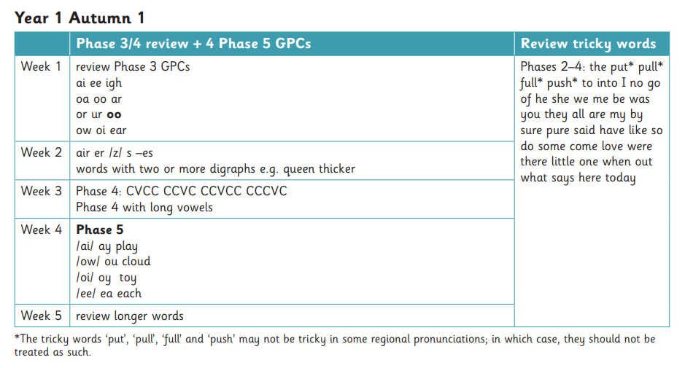

Reading targets – Autumn A 2024

Group | Owls | Foxes | Rabbits
Book band target end of half term | Yellow/Blue | Yellow/Blue | Yellow/Blue
Reading target for end of half term | WT1  Read cvc words containing the first 26 graphemes confidently without overt sounding and blending.  Read words containing most Phase 3 graphemes.  Read words (Phase 4) containing adjacent consonants in the: Initial and final position  Read words containing plural ‘s’.  Use phonics knowledge independently within reading to attempt unfamiliar phase 4 words.  Read a sentence as a whole sentence (rather than word to word).  Read familiar sentences independently with developing pace. | WT1  Read cvc words containing the first 26 graphemes confidently without overt sounding and blending.  Read words containing most Phase 3 graphemes.  Read words (Phase 4) containing adjacent consonants in the: Initial and final position  Read words containing plural ‘s’.  Use phonics knowledge independently within reading to attempt unfamiliar phase 4 words.  Read a sentence as a whole sentence (rather than word to word).  Read familiar sentences independently with developing pace. | WT1  Read cvc words containing the first 26 graphemes confidently without overt sounding and blending.  Read words containing most Phase 3 graphemes.  Read words (Phase 4) containing adjacent consonants in the: Initial and final position  Read words containing plural ‘s’.  Use phonics knowledge independently within reading to attempt unfamiliar phase 4 words.  Read a sentence as a whole sentence (rather than word to word).  Read familiar sentences independently with developing pace.
Reading focus for half term | Behave like a reader and knows how books work when reading for pleasure.  Listen and respond appropriately to stories, poetry and non-fiction texts.  Re-tell familiar stories, identifying some key events.  To notice different expressions from stories read to them.  Begin to understand the difference between stories and information texts.  Read simple sentences, pausing at a full stop.  Predict what may happen next in a fiction text | Behave like a reader and knows how books work when reading for pleasure.  Listen and respond appropriately to stories, poetry and non-fiction texts.  Re-tell familiar stories, identifying some key events.  To notice different expressions from stories read to them.  Begin to understand the difference between stories and information texts.  Read simple sentences, pausing at a full stop.  Predict what may happen next in a fiction text | Behave like a reader and knows how books work when reading for pleasure.  Listen and respond appropriately to stories, poetry and non-fiction texts.  Re-tell familiar stories, identifying some key events.  To notice different expressions from stories read to them.  Begin to understand the difference between stories and information texts.  Read simple sentences, pausing at a full stop.  Predict what may happen next in a fiction text

Writing targets – Autumn A 2024

Group | Owls | Foxes | Rabbits
Writing target end of half term | WT1 | WT1 | WT1
Writing focus for half term | - Independently compose sentences orally or mentally before writing.  - Combine sentences using the conjunctions and  - Correctly use a capital letter to show the start of sentences.  - Correctly use a full stop to show the end of sentences.  - Add an adjective to a noun to create a noun phrase.  - Spell many words correctly (phase 3) and others phonetically plausibly independently.  - When used, spell many year one tricky words correctly.  - Use most letter names to spell words aloud. | - Independently compose sentences orally or mentally before writing.  - Combine sentences using the conjunctions and  - Correctly use a capital letter to show the start of sentences.  - Correctly use a full stop to show the end of sentences.  - Add an adjective to a noun to create a noun phrase.  - Spell many words correctly (phase 3) and others phonetically plausibly independently.  - When used, spell many year one tricky words correctly.  - Use most letter names to spell words aloud. | - Independently compose sentences orally or mentally before writing.  - Combine sentences using the conjunctions and  - Correctly use a capital letter to show the start of sentences.  - Correctly use a full stop to show the end of sentences.  - Add an adjective to a noun to create a noun phrase.  - Spell many words correctly (phase 3) and others phonetically plausibly independently.  - When used, spell many year one tricky words correctly.  Use most letter names to spell words aloud.
Physical development / fine motor skills focus | Form many letters in the correct direction, starting and finishing in the right place, sitting on the line.  Capital letters:  Lower case letters:  Use spaces between words.  Keep consistent letter size most of the time. | Form many letters in the correct direction, starting and finishing in the right place, sitting on the line.  Capital letters:  Lower case letters:  Use spaces between words.  Keep consistent letter size most of the time. | Form many letters in the correct direction, starting and finishing in the right place, sitting on the line.  Capital letters:  Lower case letters:  Use spaces between words.  Keep consistent letter size most of the time.

Penpals Handwriting Autumn A 2024

Group | Owls | Foxes | Rabbits
Week 1 |  | Theme week
Week 2 |  | Theme week
Week 3  Year 1 Term 1 unit 1 | Practise long legged giraffe letters | Practise long legged giraffe letters | Practise long legged giraffe letters
Week 4  Year 1 Term 1 unit 2 | Writing words with ll | Writing words with ll | Writing words with ll
Week 5  Year 1 Term 1 unit 3 | Introducing capitals with long legged giraffe letters | Introducing capitals with long legged giraffe letters | Introducing capitals with long legged giraffe letters
Week 6  Year 1 term 1 unit 4 | Practise one armed robot letters | Practise one armed robot letters | Practise one armed robot letters
Week 7 and 8  Year 1 term 1 unit 5 | Practise long legged giraffe and one armed robot letters | Practise long legged giraffe and one armed robot letters | Practise long legged giraffe and one armed robot letters

