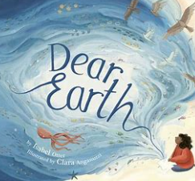
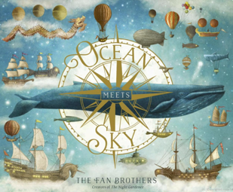
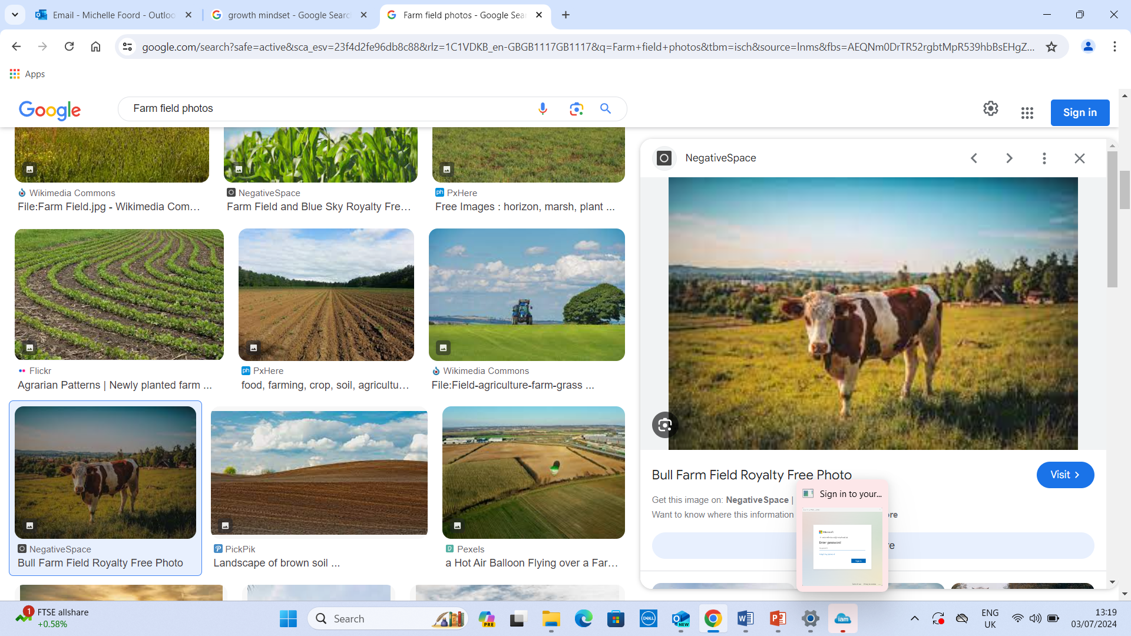


Paddington Class (Year 2)
Mathematics Medium Term Planning with differentiation.
Summer B – 2025
Whole school theme: Food and Farming
Literacy Tree stories: Ocean Meets Sky & Dear Earth
What is out there?
Activities and groups adapted as necessary following on going formative assessments.

Week | Starters |  | YELLOW STARS (EXP2/GD2)  RED TRIANGLE (EXP2)    All below to be done with adult keeping children on task. Using concrete apparatus initially then pictorial representations. Then finally moving to mentally and independently. |  | BLUE CIRCLES (EMG2/EXP2)  All below to be done with support as necessary. Initially, using concrete apparatus, then moving to pictorial representations.
Week  1  02.06.25-06.06.25 |  | EMC:  Count forwards to 100 from 0.  Count backwards from any given number.  Number bonds to 10 and 100.  Read numbers from 1 – 20 in words.  Write numbers from 1 – 20 in words.  Starter:  Counting in 2, 5 and 10.  Reciting 2x tables.  Reciting 10x tables.  Reciting 5x tables. |  | YELLOW STARS & RED TRIANGLE & BLUE CIRCLES  SATS TESTS
Week  2  09.06.25-13.06.25  Literacy Tree  Non-Fiction  Week 1 |  | EMC:  Count forwards to 100 from 0.  Count backwards from any given number.  Number bonds to 10 and 100.  Read numbers from 1 – 20 in words.  Write numbers from 1 – 20 in words.  Starter:  Counting in 2, 5 and 10.  Reciting 2x tables.  Reciting 10x tables.  Reciting 5x tables. | YELLOW STARS & RED TRIANGLE & BLUE CIRCLES  Statistics: Small steps  Make tally charts.  Tables.  Block diagrams.  Draw pictograms (1-1)  Statistics.  Collect data and present and record it as a simple list.  Collect data and present and record it as a tally chart.  Collect data and present and record it as a block diagram.  Construct own tables to present data as a simple list.  Construct own tables to present data as a tally chart.  Construct own tables to present data as a block diagram.  Working mathematically  Record different methods using a variety of formats.  Use own ideas to create own records.  Sort and classify giving reasons for choices.  Make comparisons and order using <,> & =.  Identify the need for and use equipment correctly.  Show fluency.  Show varied fluency.  Show reasoning and problem solving skills.  Speaking and Listening  Vocabulary – Use words from one experience to link to other experiences.  Listening and understanding – Ask questions to show active listening.  Speaking and presenting - Use gesture, intonation and expression to aid meaning in stories, poems, NF, questioning.  Creativity – Develop a story from a starting point.  Social interaction – Sometimes take on the role of leader.
Week  3  16.06.25-20.06.25  Literacy Tree  Non-Fiction  Week 2 |  | EMC:  Count to and back to 100, from a given number.  Count forwards and backwards to 20/50/100 from 0.  Reliably count up to 20/50/ 100 objects.  Starter:  Counting in 2, 5 and 10.  Reciting 2x tables.  Reciting 10x tables.  Reciting 5x tables. | YELLOW STARS & RED TRIANGLE & BLUE CIRCLES  Statistics: Small steps  Interpret pictograms (1-1)  Draw pictograms (2, 5 & 10)  Interpret pictograms (2, 5 & 10)  Statistics.  Collect data and present and record it as a simple pictogram.  Collect data and present and record it as a block diagram.  Construct own tables to present data as a simple list.  Construct own tables to present data as a tally chart.  Construct own tables to present data as a simple pictogram.  Construct own tables to present data as a block diagram.  Working mathematically  Record different methods using a variety of formats.  Use own ideas to create own records.  Sort and classify giving reasons for choices.  Make comparisons and order using <,> & =.  Identify the need for and use equipment correctly.  Show fluency.  Show varied fluency.  Show reasoning and problem solving skills.  Speaking and Listening  Vocabulary – Use words from one experience to link to other experiences.  Listening and understanding – Ask questions to show active listening.  Speaking and presenting - Use gesture, intonation and expression to aid meaning in stories, poems, NF, questioning.  Creativity – Develop a story from a starting point.  Social interaction – Sometimes take on the role of leader.
Week  4  23.06.25-27.06.25  Literacy Tree  Non-Fiction  Week 3 |  | EMC:  Count forwards and backwards to 20/50/100 from 0 and from any given number.  Read numbers from 1 to 20 in words.  Write numbers from 1 to 20 in words.  Count forward in 10’s, 5’s and 2’s.  Starter:  Counting in 2, 5 and 10.  Reciting 2x tables.  Reciting 10x tables.  Reciting 5x tables.. | YELLOW STARS & RED TRIANGLE & BLUE CIRCLES  Position and Direction: Small steps  Language of position.  Describe movement.  Describe turns.  Describe movement and turns.  Shape patterns with turns.  Geometry – Position and Direction  Distinguish between rotations as a turn,  Distinguish between rotations as quarters or as a right angle.  Distinguish between rotations as a half and three-quarter turn.  Distinguish between rotations as clockwise and anti-clockwise.  Distinguish between rotations as left and right.  Working mathematically  Record different methods using a variety of formats.  Use own ideas to create own records.  Sort and classify giving reasons for choices.  Make comparisons and order using <,> & =.  Identify the need for and use equipment correctly.  Show fluency.  Show varied fluency.  Show reasoning and problem solving skills.  Speaking and Listening  Social interaction – Sometimes take on the role of leader.  Speaking and presenting - Use gesture, intonation and expression to aid meaning in stories, poems, NF, questioning.  Creativity – Develop a story from a starting point.  Use words from one experience to link to other experiences.  Listening and understanding – Ask questions to show active listening.  Social interaction - Understand the need to talk in a different way to different people
Week  5  30.06.25-04.07.25  Transition day  02.07.25  Tuesday 01.07.25  NP Trip  Thursday 03.07.25 Paddington trip  Assessment Week – including writing assessments and White Rose maths progress checks. |  | EMC  Count to and back to 100, from a given number.  Read numbers from 1 to 20 in words.  Write numbers from 1 to 20 in words.  Starter:  Counting in 2, 5 and 10.  Reciting 2x tables.  Reciting 10x tables.  Reciting 5x tables. | YELLOW STARS & RED TRIANGLE & BLUE CIRCLES  Investigations  Number pyramids.  Chn to reason about addition to solve a series of number pyramids.  Always? Sometimes? Never?  In small groups solve maths investigation involving odd and even numbers.  02.07.24 – Transition day at Academy.  Heads and Feet.  Chn to work out different combinations of numbers to total the same amount.  https://nrich.maths.org/924/note  Domino sequences.  Chn to investigate number sequences and patterns.  https://nrich.maths.org/241/note  Speaking and Listening  Creativity – Develop a story from a starting point.  Social interaction – Sometimes take on the role of leader.  Listening and understanding – Ask questions to show active listening.  Speaking and presenting - Use gesture, intonation and expression to aid meaning in stories, poems, NF, questioning.  Social interaction - Understand the need to talk in a different way to different people.  Vocabulary – Use words from one experience to link to other experiences.
Week  6  07.07.25-11.07.25  Theme week – transition  10.06.25  PE transition day |  | EMC:  Number bonds to 10  Count aloud in 2’s, 5’s and 10’s.  Read numbers from 1 to 20 in words.  Write numbers from 1 to 20 in words.  Starter:  Counting in 2, 5 and 10.  Reciting 2x tables.  Reciting 10x tables.  Reciting 5x tables. | YELLOW STARS & RED TRIANGLE & BLUE CIRCLES  Theme Week – Transition.  See separate planning.

Week  7  14.07.25-18.07.25  Leavers assembly 10am 16.07  Celebration Week | EMC:  Count in 2, 3, 5 & 10.  Starter: | YELLOW STARS & RED TRIANGLE & BLUE CIRCLES  Theme Week – Celebration.  See separate planning.

