Ongoing curriculum
PSED: Jigsaw: Piece 1: Being me in My World
Music: Kapow Music Unit: Exploring Sound
RE: Special Me
PE: Multi Skills
ESafety; Active Bytes (to be done first week)

What animals come out at night?
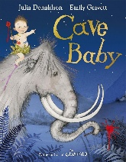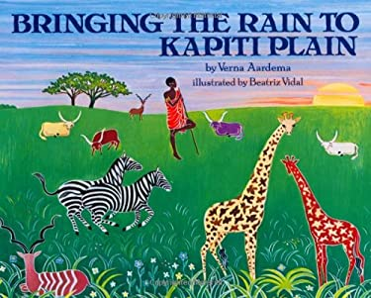

Technology
-Follow e-safety programme. Talk about e-safety and how to stay safe online by not clicking on things you are unsure about and understanding who a trusted adult is.
Data handling:
-Use the internet to research owls, look at owl photos, sounds and videos.

PSED:
-Discuss feelings within the owl baby family and make links to our own feeling associated

EAD: Creating with Materials
Art/ DT
- Explore clay texture and clay tools. Practise manipulating clay by making shapes and patterns. Build up skills in order to make a clay owl or tree.
-Talk about art mediums both natural materials and pastels, crayons, pencils, charcoal and wax. Make bark and leaf rubbing/ printing.
- Use charcoal, wax crayons etc. to make a observational drawing of a tree.
- Create a leaf art with focus on making a picture of a nocturnal animal or a feature of woodland habitat.
- Explore collage techniques including natural and man-made materials including tissue paper etc.
- Explore descriptive language related to texture and describe materials and textures.
- Use the light box to represent nighttime scene in the woodlands.

EAD: Being Imaginative and Expressive
-Name musical instruments and use various materials explored in art lessons to make own instruments. Make instruments to create woodland sounds and retell the story.
-
PD: Fine/gross motor skills
-Thread string through leaves.
-Thread natural resources within a forest school environment.
- Use small tools to manipulate clay.
-Control scissors when cutting natural materials and collage art materials.

UTW: People, Culture and Communities
- Discuss trees in the immediate environment and similarities and differences across these.
- Talk about the family connections within the owl babies story and discuss similarities and differences across our families.
- Look at young and adult animals within families. Match young and adult animals. Talk about growth and make links to features of animals.

Literacy focus:
Cave Baby/Bringing the Rain to Kapiti Plain
Listening, Attention and Understanding:
Speaking:
Talk about feelings and experiences of day and night. Use senses vocabulary to describe what you can see and hear during the night.
Use descriptive vocabulary to describe the texture of materials.
Describe the woodland setting and the animals in this habitat.
Describe features of woodland animals.
Use past and present tenses when exploring young and adult animals.
Ask questions in relation to the woodland habitat and animals.
UTW: Natural World
-Discover nocturnal animals and describe features including owls, bats, badgers, hedgehogs and foxes.
- Discuss what a habitat is and talk about features of a woodland habitat. Discuss similarities and differences across habitats in relation to woodlands. Name and describe features of animals within a woodland habitat.
- Make observational drawings of trees and talk about tree growth.
- Talk about seasonal change including weather and tree changes.
- Talk about how to take care of the natural world.
- Discuss day/night and light/ dark.
- Name sources of light (science) including sun, torches, stars and lights.
- Engage in small world space (stars/ night).
- Participate in a ‘camping’ style activity where children can experience camping, den building, hot chocolates etc.
Numeracy: White Rose
Number:
Counting, Cardinality, Subitising, Composition and Comparison
Numerical Patterns:
Patterns
Measure

