Literacy focus:
Literacy Tree
I am Henry Finch by Alexis Deacon
Guidebook - How to think
Listening, Attention and Understanding:
Speaking:
Understand why questions
Use longer sentences of four to six words
Be able to express a point of view and to debate when they disagree with an adult or a friend, using words as well as actions.

Where do we live?
I am Henry Finch / Look Up
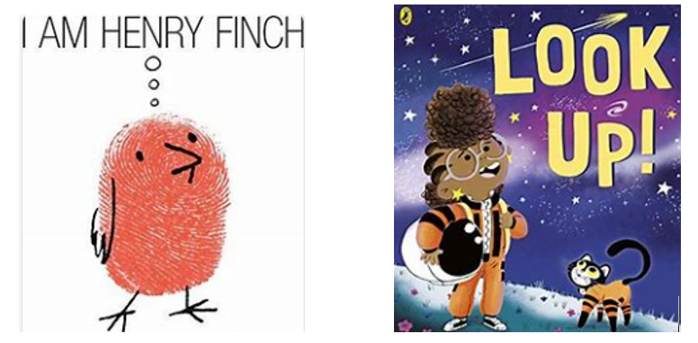
PD: Fine/gross motor skills
- Running races and other energetic movements, such as skipping, hopping etc.
- Cook gingerbread, using cutlery and tools
- Scissor skills for making a puppet
- Use a range of paintbrushes: fine and thick, rollers
- Talk about water safety
- Talk about road safety

Technology
- Programme Beebots over a bridge
- Use the Internet to look at pictures of bridges and rivers
- Use the Internet to look at maps and aerial views

UTW: People, Culture and Communities
- Experience: local town walk, looking at bridges, Friday market
- Look at towns from different countries, drawing on stories and maps to make comparisons
- Describe where we live, making observations and looking at maps
- Talk about our community, looking at the similarities and differences between cultures in our area
- Talk and describe the rivers and bridges in Bridgwater
- Look at markets in Bridgwater and different countries, using this to explore similarities and differences

UTW: Natural World
- Experience: local town walk, looking at bridges, Friday market
- Talk about the features of environments, including towns
- Talk about own experiences of their immediate environment
- Recognise features of towns from aerial views
- Compare and contrast environments (similarities and differences), including towns
- Talk about how to look after the environments, such as recycling
- Understand the importance of changing states, such as melting
- Explore floating and sinking

UTW Past and Present
- Invent and adapt a story with other children and adults
- Explore beat and rhythm relaxed to the story
- Move in different ways to music, focusing on moving in time to music
- Perform the story with peers to recount

EAD: Creating with Materials
Art/ DT
- Explore colour mixing techniques
- Make a puppet from the story, utilizing a variety of materials e.g. card, felt, paper. Use the puppet when retelling the story
- Build a bridge collaboratively, paying attention to function
- Make a Gingerbread Man, paper dolly string
- Design own Gingerbread Man, sharing the creation and describing the process
- Talk about the need for safety when using tools

PSED:
- Talk about trust and who to trust
- Talk about friendship, showing an understanding of others feelings and sensitivity
- Name and talk about feelings
- Talk about own abilities, self-confidence and resilience
- Set and work towards own goal over the half term
- Work and play cooperatively when building a group bridge

Ongoing curriculum
PSED: Jigsaw – Puzzle 2 Celebrating Difference
Music: Nativity Songs
RE: Special Times
PE: Ball Skills – Yoga/Dance if inside
ESafety; Active Bytes (to be done first week)

Numeracy:
Mastering Number:
Comparison, Counting, Ordinality, Cardinality and Composition
White Rose:
Circles and triangles
Shapes with 4 sides

