UTW: Natural World
- Talk about hot and cold environments and houses. Look at Antarctica and icy environments.
- Talk about ice features and the changes states of matter. Ice experiments linked to igloos
-Ice play
- Explore how light travels through materials when making our homes.
- Talk about natural homes including homes for animals.
Ongoing curriculum
PSED: Jigsaw. Puzzle 3 – Dreams and Goals
Music: Kapow – Music and Movement
RE: Special places
PE: Gymnastics
ESafety; Active Bytes Building Healthy Habits – Being Kind Online

Literacy Tree
Billy and the Beast by Nadia Shireen
Instructions – For a meal that a monster might make

Listening, Attention and Understanding & Speaking -Talk about what a family is and make comparisons between them. Describe features of homes. Use directional language to explain route to school.
- Use past, present and future tenses when explaining own history and future life.
- Ask questions about their peers house and family life.
- Use evaluation language when making homes.
UTW: People, Culture and Communities
- Talk about what a home is using photographs and name the different types of homes. Look at similarities and differences across the home.
- Take photograph on own home to put on own 3D home model.
Talk about homes from different cultures and countries e.g igloos.
- Go on local walk to discover different homes in our local area and name external features of a home
- Experience: brick and tile museum
- Define families and feelings/ experiences associated with families. Talk about different families, including families from different traditions and cultures,
- Look at roles and cultural expectations within families
- Look at similarities and difference between own families, children to bring in pictures.
- Look at examples of maps and learn map language. Look at a map showing route to school and draw on map to school, looking at left, right, near, far
- Draw map of three little pigs journey
- Talk about roles in society within our school and local area e.g. police, fire service, doctors, teachers. Make links to our story- who keeps us safe etc.
-Home corner – Police Station enhancement

PD: Fine/gross motor skills
- Participate in obstacle courses related to our map and journey work. Discuss what an obstacle course is and language associated with this such as over, under, forwards, backwards relating to maps and journeys
-Show good control of using tools for joining and making a tile.
- Using scissors to cut materials.
Technology

-Technology in our lives: looking at technology uses in home and school
- Name different technologies and how we can use this to capture our learning e.g cameras for photographs and ipads for filming. What is a film? Make a film of the little pigs journey

Who lives in a house like this?
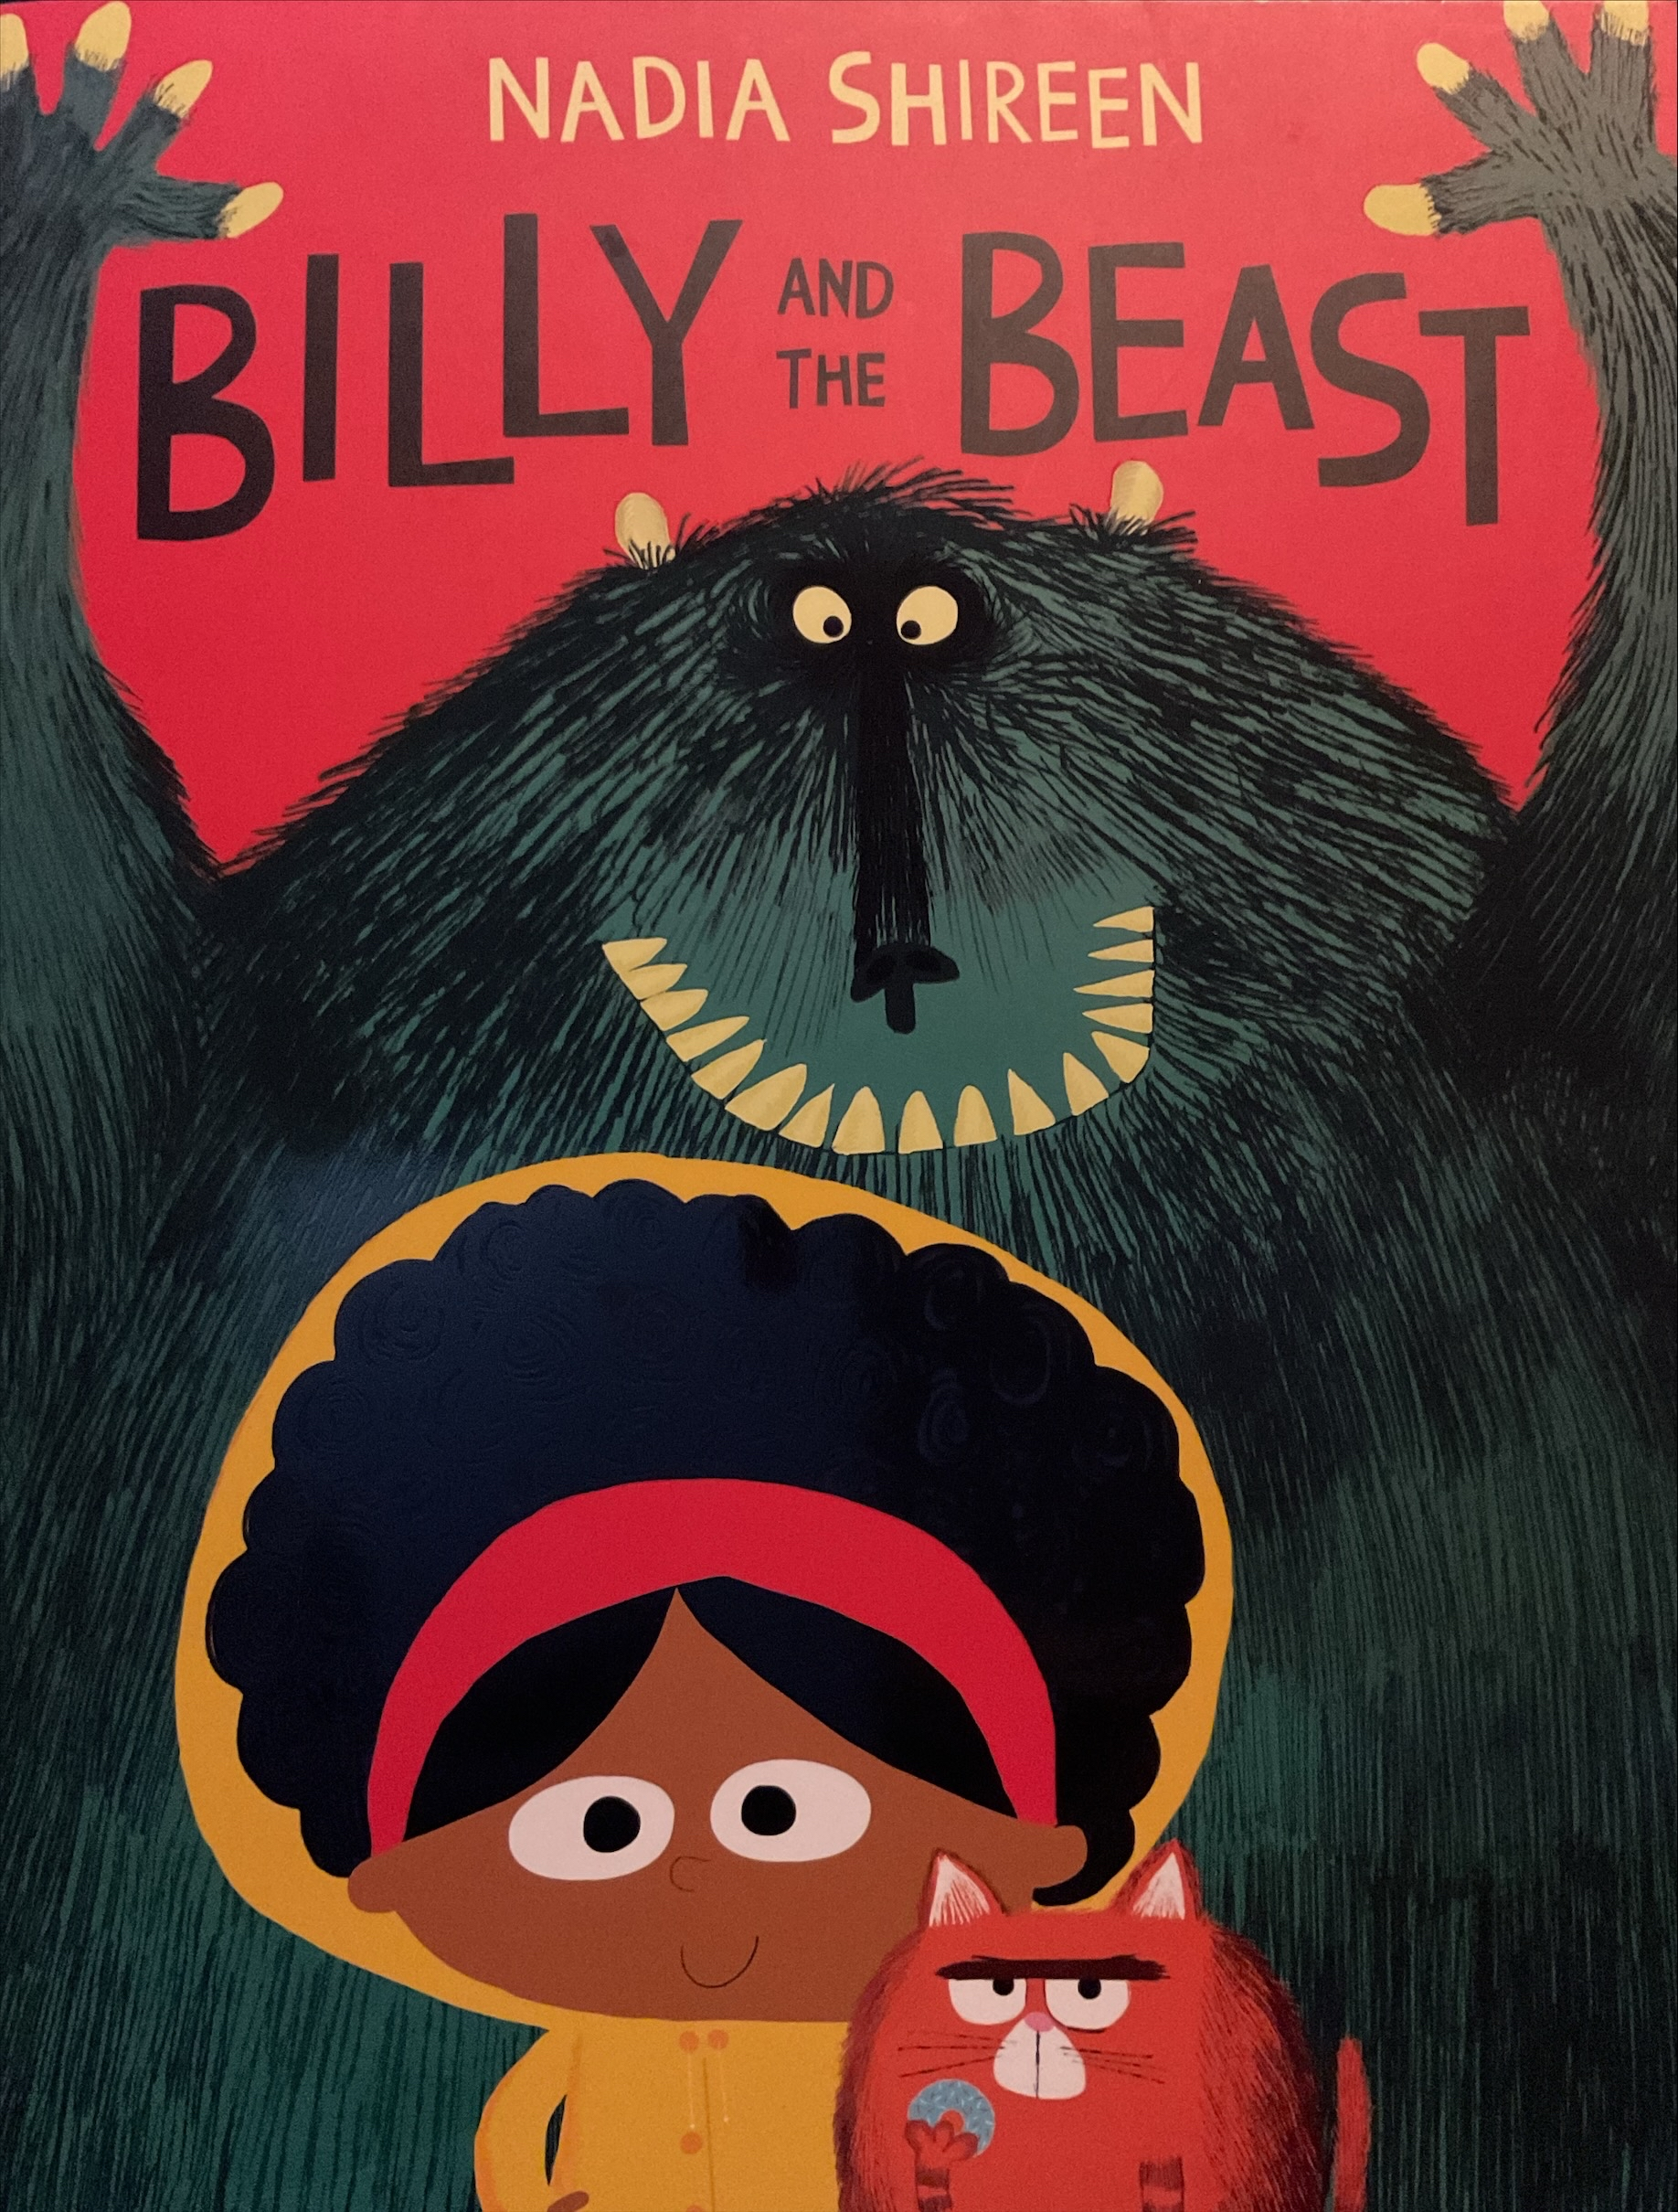

UTW Past and Present
- Talk about the lives of people around us (links with PCC)
- Talk about the little pigs at a young age and growing up. Look at pictures of children’s past growing up. Talk about change. Sequence pictures of our lives.
- Talk about the little pigs growing up and make links to our own lives of what we want to do when we grow up.
-

EAD: Creating with Materials
Art/ DT
- Draw different parts of a home linking to language explored on local walk e.g drawing windows, doors, bricks etc. using pencils. Talk about shapes of different features.
- Draw a home and name different parts and materials. Use shape language.
-Name materials and learn descriptive vocabulary to describe texture/ properties.
-Name different joining techniques and explore this before final produce.
-Use various materials to make 3D homes.
-Create homes collaboratively: sharing ideas and resources including construction objects and materials.
-Use charcoal to draw a house (homes from the past).
-Draw a map of the pigs journey and own journey to school.
Final product: making a tile at the brick and tile museum.
PSED:
- Talk about feelings linked to families and change (growing up)
- Work co-operatively to build homes.
- Show resilience and perseverance through home building.
- Rules within the home and talk about respecting relationships.

Numeracy:
Mastering Number:
Subitising Comparison, Counting, Ordinality, Cardinality and Composition
White Rose:
Length and height
Capacity

